

 Pre-Travel information

Pre-Travel Information
Now that you have decided on taking one of our great RV’s on a North American road trip, we wanted to share with you some useful information to help you get ready and prepared for your upcoming adventure.
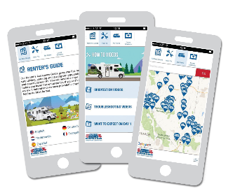
Cruise America/Cruise Canada App
Download our FREE App with a number of helpful resources including videos & renter’s assistance guide.


Cruise America Tourbook
Look in our Tourbook for more information about our products, camping, tips and over 35 sample routes throughout North America https://www.rvcheckin.com/tourbook.asp

Our website
www.rvcheckin.com
Our site offers you a whole host of great information when planning your RV holiday. As well as being able to enter your details to speed up the check-in process at the depot, you can also find the following:
- Customer Orientation video https://www.rvcheckin.com/orientation.asp
- What to expect when you arrive at our depots https://www.rvcheckin.com/day1.asp
- Client essential notes https://www.rvcheckin.com/essential.asp
- Features of the RV type you will be hiring https://www.rvcheckin.com/video/default.asp
- Exciting virtual tours on the RV’s https://www.rvcheckin.com/vehicle-360/default.asp
- Where to find our depots https://www.rvcheckin.com/maps.asp
We look forward to welcoming you on your Cruise America/Cruise Canada adventure. If you are on Instagram, follow cruiseamerica and include #cruiseamericarv & #betherenow in a post.
